**EXPERIMENT NO. 4**

**NAME:** Arya Manoj Madhavi

**CLASS:** D15B

**ROLL NO.:** 31

**Aim: To install Kubectl and execute Kubectl commands to manage the Kubernetes cluster and deploy Your First Kubernetes Application.**

**Step 1:** Log in to your AWS Academy/personal account and launch a new Ec2 Instance. Select Ubuntu as AMI and t2.medium as Instance Type, create a key of type RSA with .pem extension, and move the downloaded key to the new folder.

Note: A minimum of 2 CPUs are required so Please select t2.medium and do not forget to stop the instance after the experiment because it is not available in the free tier.

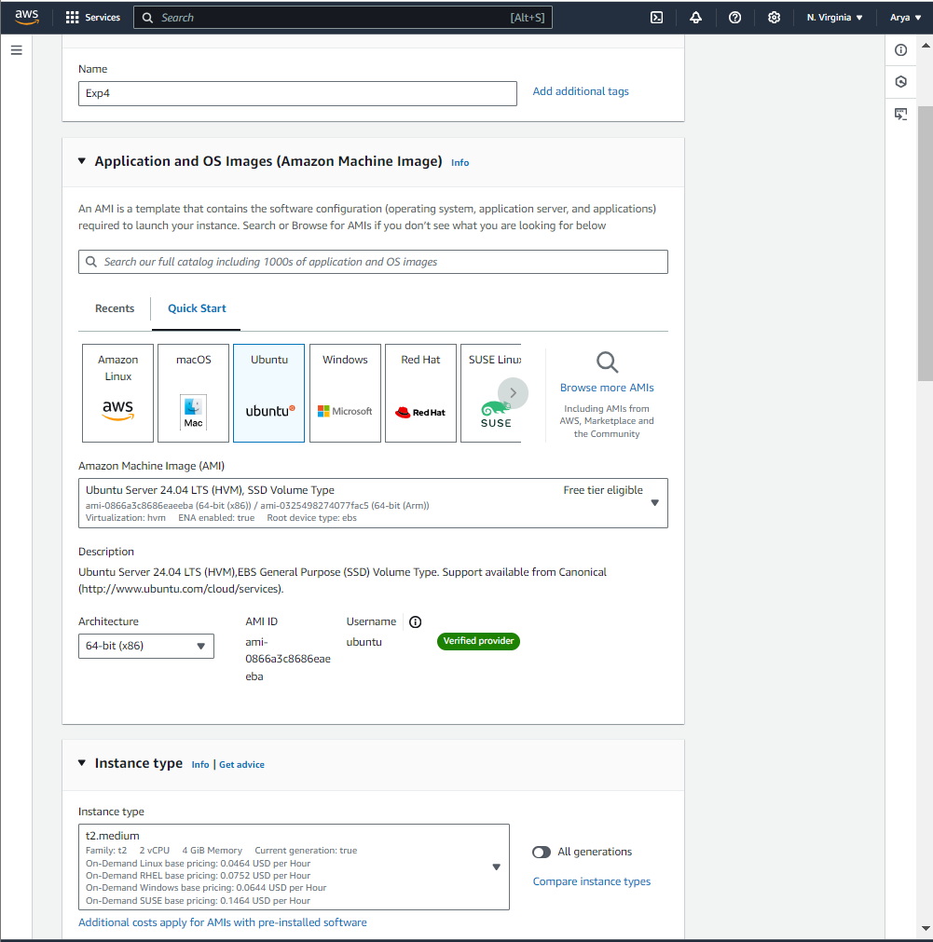

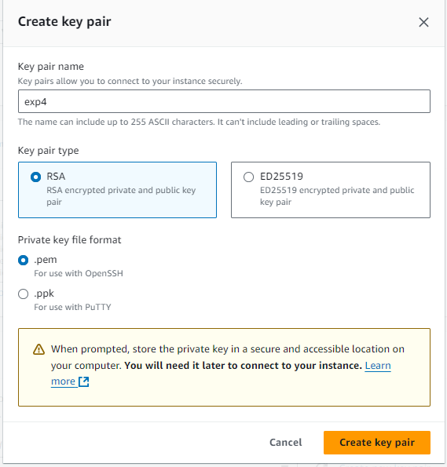

**Step 2:** After creating the instance click on Connect the instance and navigate to SSH Client.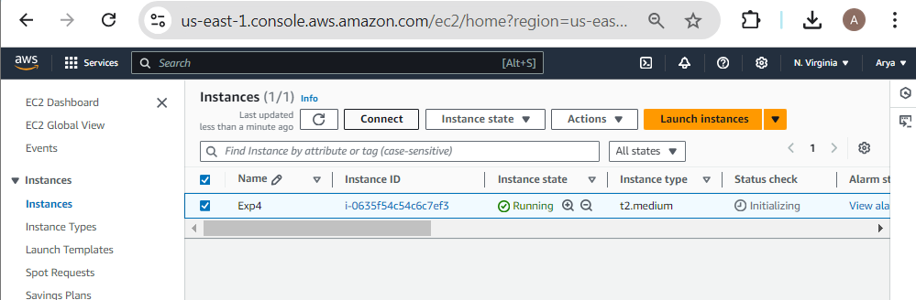

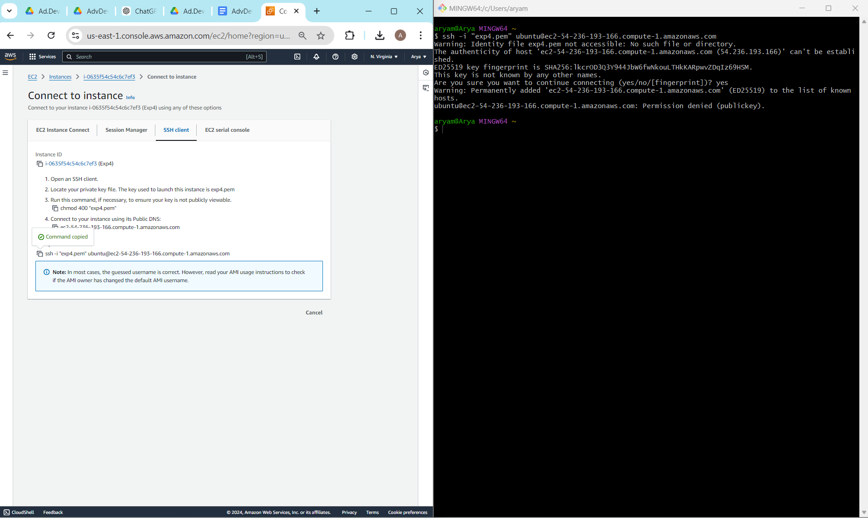 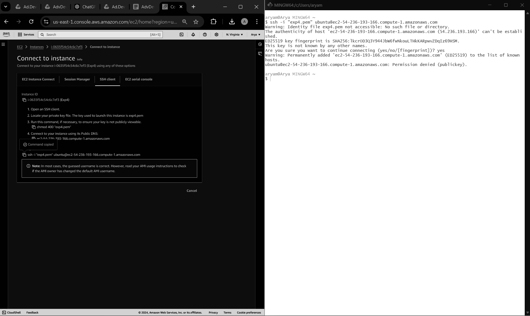

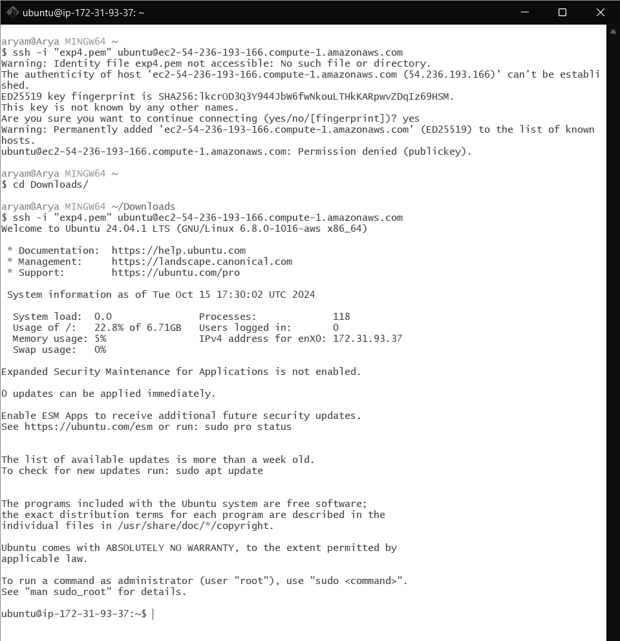

**Step 3:** Now open the folder in the terminal where our .pem key is stored and paste the Example command (starting with ssh -i …..) in the terminal.( ssh -i "Master_Ec2_Key.pem" ubuntu@ec2-54-196-129-215.compute-1.amazonaws.com)

**Step 4:** Run the below commands to install and setup Docker.

**curl -fsSL https://download.docker.com/linux/ubuntu/gpg | sudo apt-key add - curl -fsSL https://download.docker.com/linux/ubuntu/gpg | sudo gpg --dearmor -o /etc/apt/trusted.gpg.d/docker.gpg**

**sudo add-apt-repository "deb [arch=amd64] https://download.docker.com/linux/ubuntu $(lsb_release -cs) stable"**

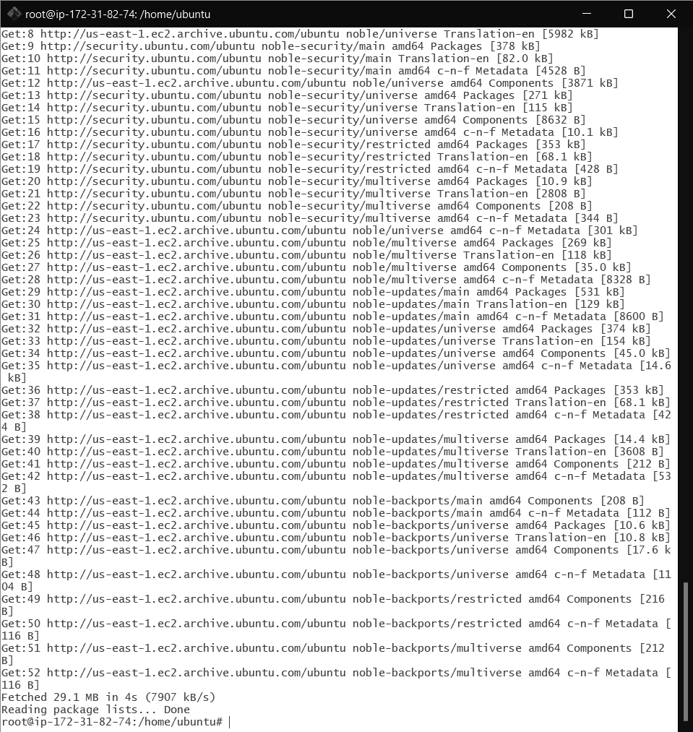

**sudo apt-get update**

**sudo apt-get install -y docker-ce**

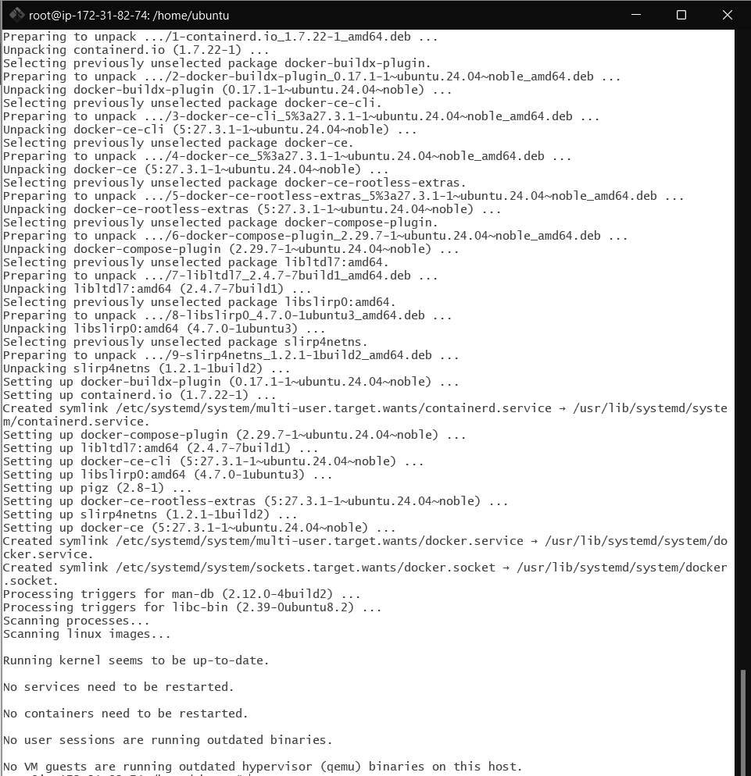

**sudo mkdir -p /etc/docker**

**cat <<EOF | sudo tee /etc/docker/daemon.json**

**{**

**"exec-opts": ["native.cgroupdriver=systemd"]**

**}**

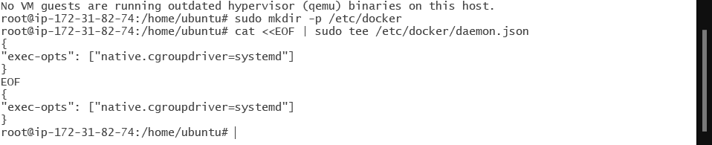

**sudo systemctl enable docker**

**sudo systemctl daemon-reload**

**sudo systemctl restart docker**



**Step 5:** Run the below command to install Kubernets.

**curl -fsSL https://pkgs.k8s.io/core:/stable:/v1.31/deb/Release.key | sudo gpg --dearmor -o /etc/apt/keyrings/kubernetes-apt-keyring.gpg**

**echo 'deb [signed-by=/etc/apt/keyrings/kubernetes-apt-keyring.gpg]**

**https://pkgs.k8s.io/core:/stable:/v1.31/deb/ /' | sudo tee /etc/apt/sources.list.d/kubernetes.list **

**sudo apt-get update**

**sudo apt-get install -y kubelet kubeadm kubectl**

**sudo apt-mark hold kubelet kubeadm kubectl**

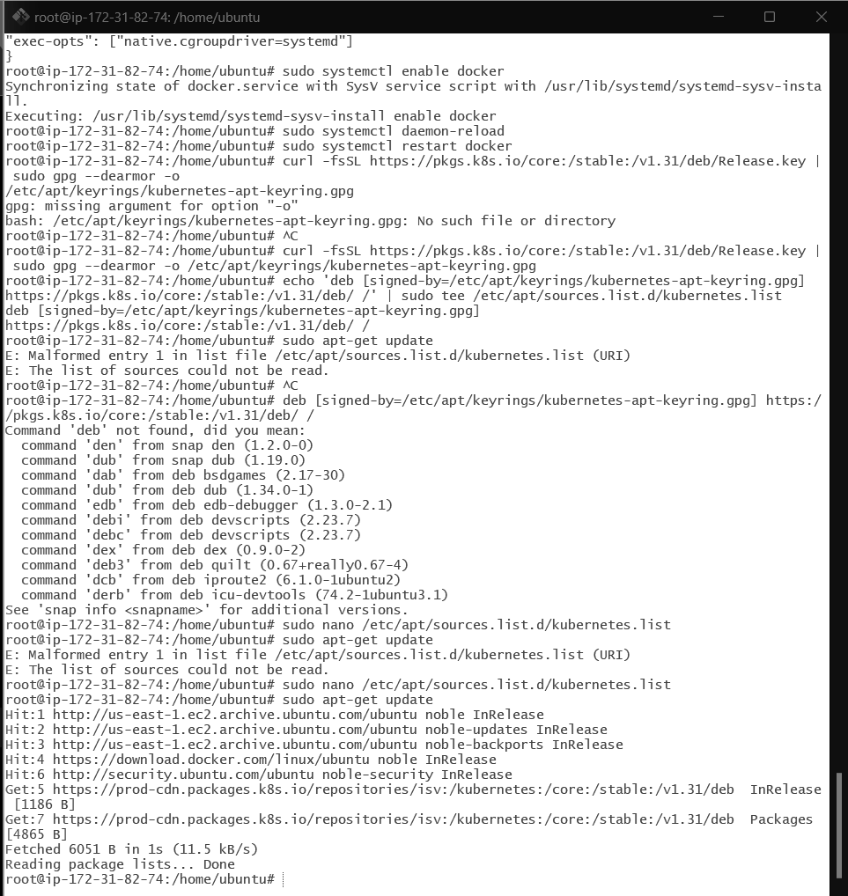

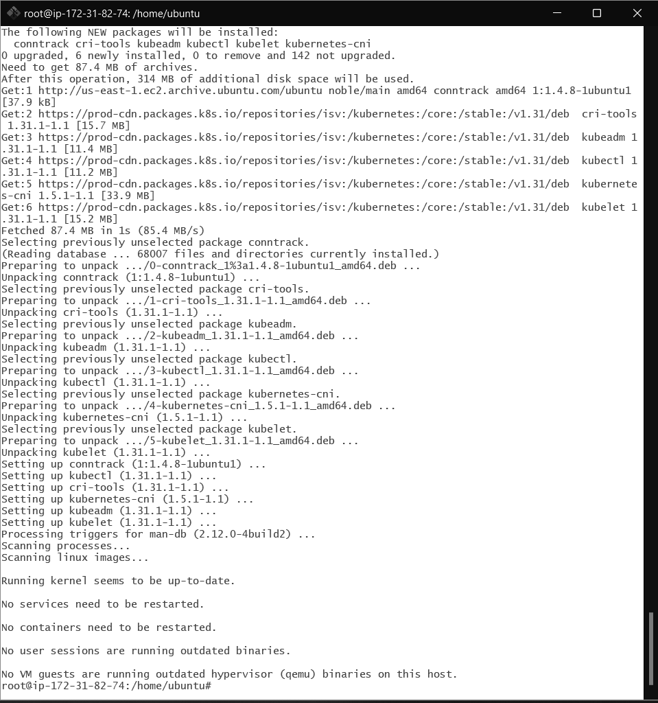

**sudo systemctl enable --now kubelet**

**sudo kubeadm init --pod-network-cidr=10.244.0.0/16**

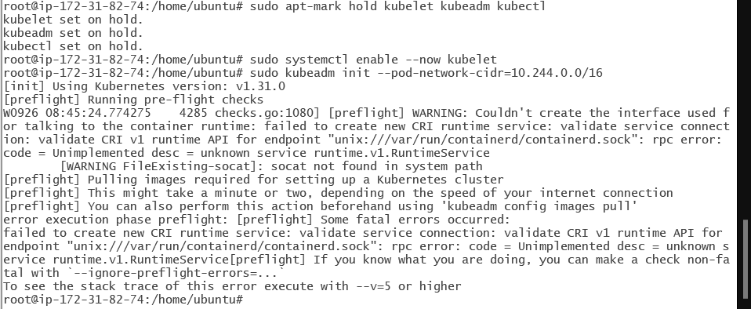

**Now We have got an error.**

**So we have to perform some additional commands as follow.**

**sudo apt-get install -y containerd**

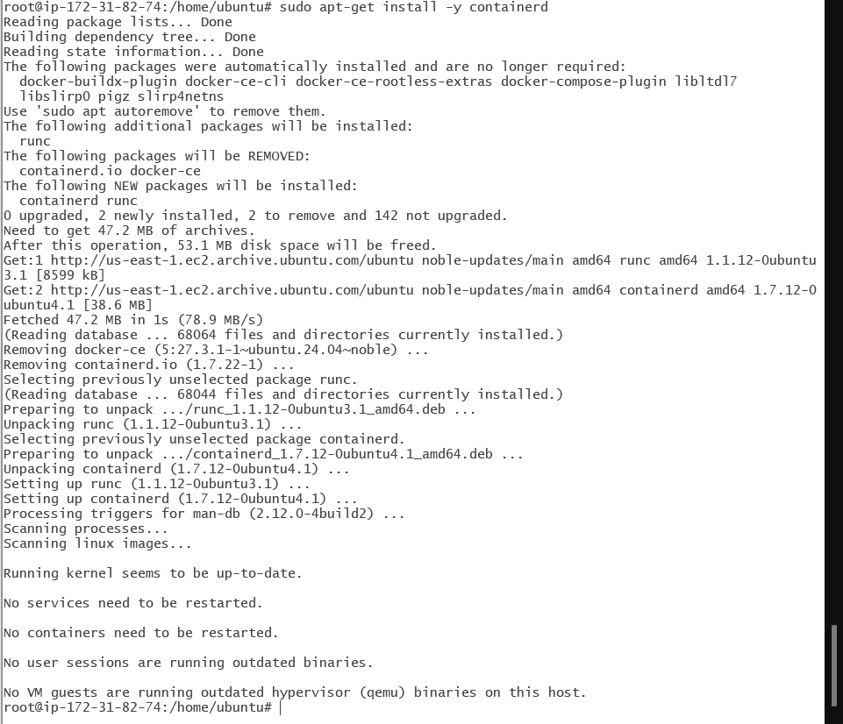

**sudo mkdir -p /etc/containerd**

**sudo containerd config default | sudo tee /etc/containerd/config.toml**

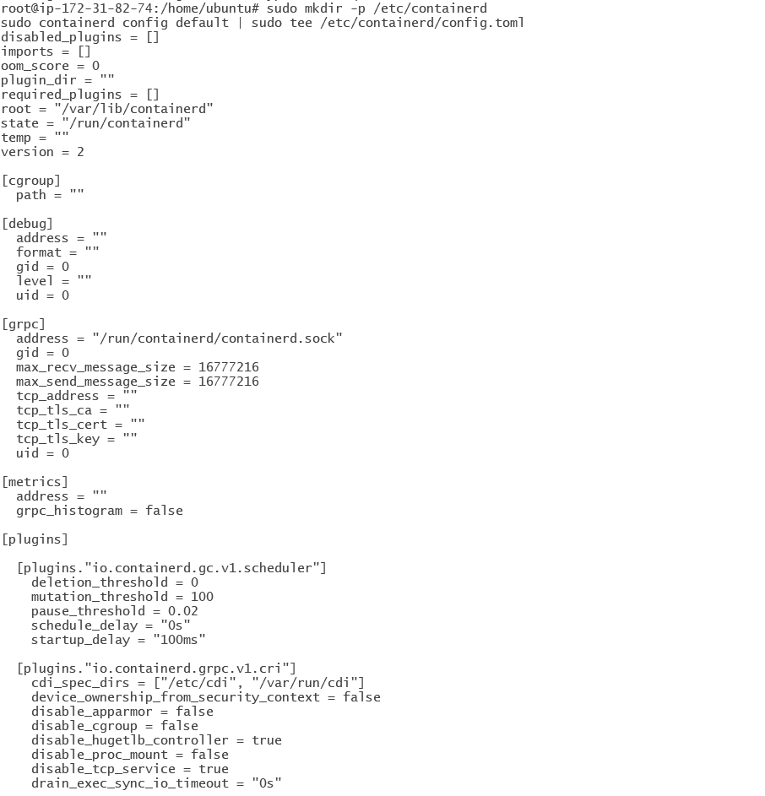

**…**

**sudo systemctl restart containerd**

**sudo systemctl enable containerd**

**sudo systemctl status containerd**

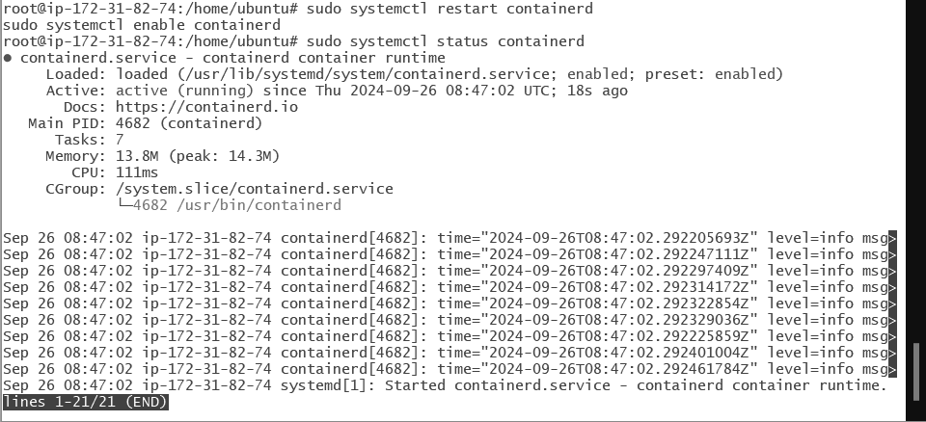

**sudo apt-get install -y socat**

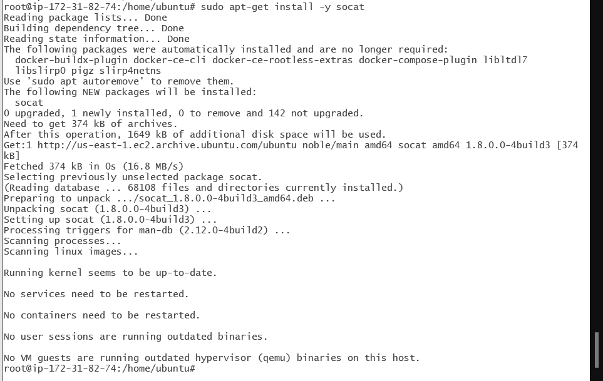

**Step 6:** Initialize the Kubecluster

**sudo kubeadm init --pod-network-cidr=10.244.0.0/16**

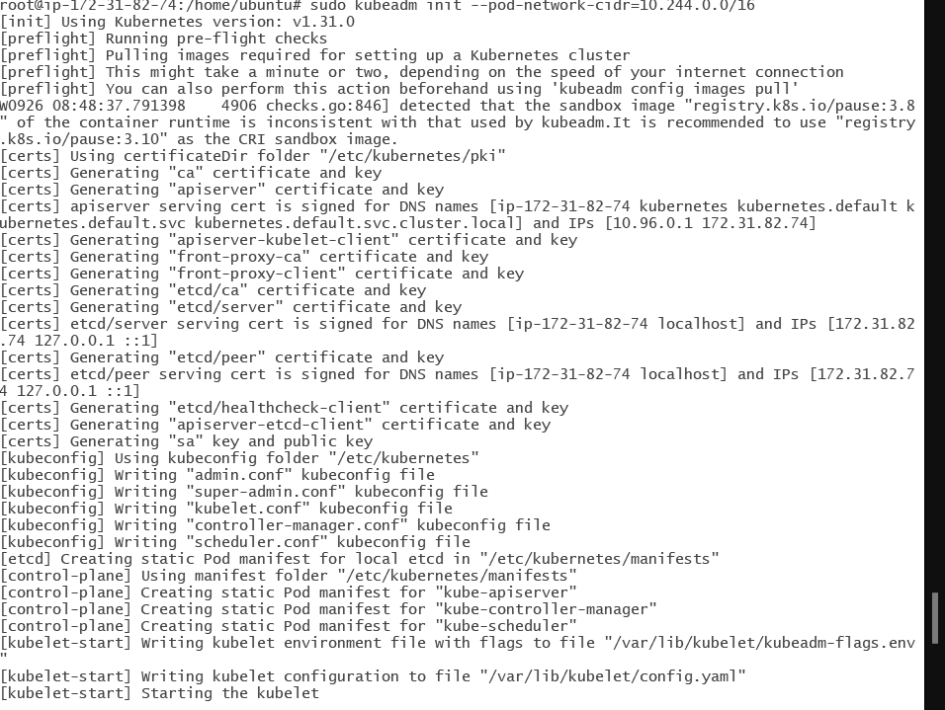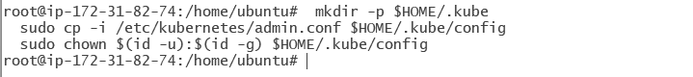

**Copy the mkdir and chown commands from the top and execute them.**

**mkdir -p $HOME/.kube**

**sudo cp -i /etc/kubernetes/admin.conf $HOME/.kube/config**

**sudo chown $(id -u):$(id -g) $HOME/.kube/config**

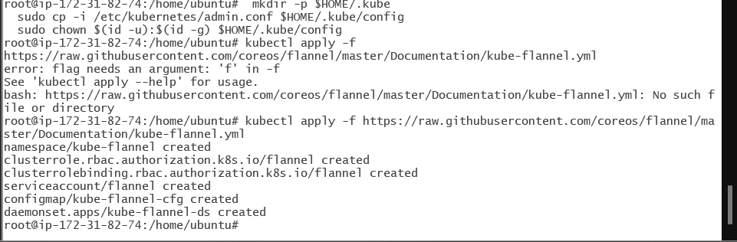

**Add a common networking plugin called flannel as mentioned in the code.**

**sudo nano /etc/apt/sources.list.d/kubernetes.list**

**deb [signed-by=/etc/apt/keyrings/kubernetes-apt-keyring.gpg] https://pkgs.k8s.io/core:/stable:/v1.31/deb/ /**

**kubectl apply -f** [**https://raw.githubusercontent.com/coreos/flannel/master/Documentation/kube-flannel.yml**](https://raw.githubusercontent.com/coreos/flannel/master/Documentation/kube-flannel.yml)

**Step 7: Now that the cluster is up and running, we can deploy our nginx server on this cluster.Apply this deployment file using this command to create a deployment**

**kubectl apply -f https://k8s.io/examples/application/deployment.yaml**

**kubectl get pods**

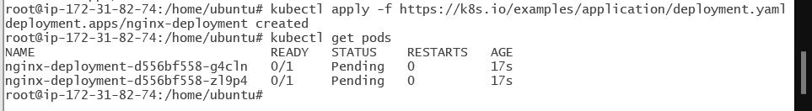**POD_NAME=$(kubectl get pods -l app=nginx -o jsonpath="{.items[0].metadata.name}")**

**kubectl port-forward $POD_NAME 8080:80**

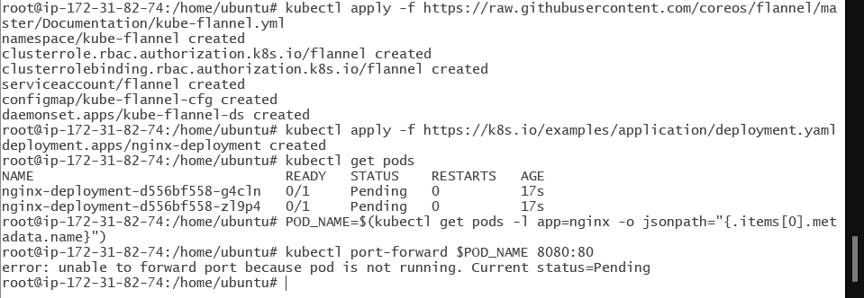

**Note : We have faced an error as pod status is pending so make it running run below commands then again run above 2 commands.**

**http://node-role.kubernetes.io/control-plane-**

**kubectl get nodes**



**kubectl get pods**

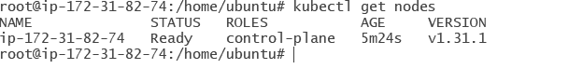**POD_NAME=$(kubectl get pods -l app=nginx -o jsonpath="{.items[0].metadata.name}")**

**kubectl port-forward $POD_NAME 8080:80**

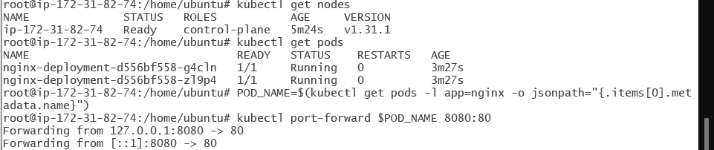

**Step 8:** Verify your deployment

Open up a new terminal and ssh to your EC2 instance.

Then, use this curl command to check if the Nginx server is running.

**curl --head http://127.0.0.1:8080**



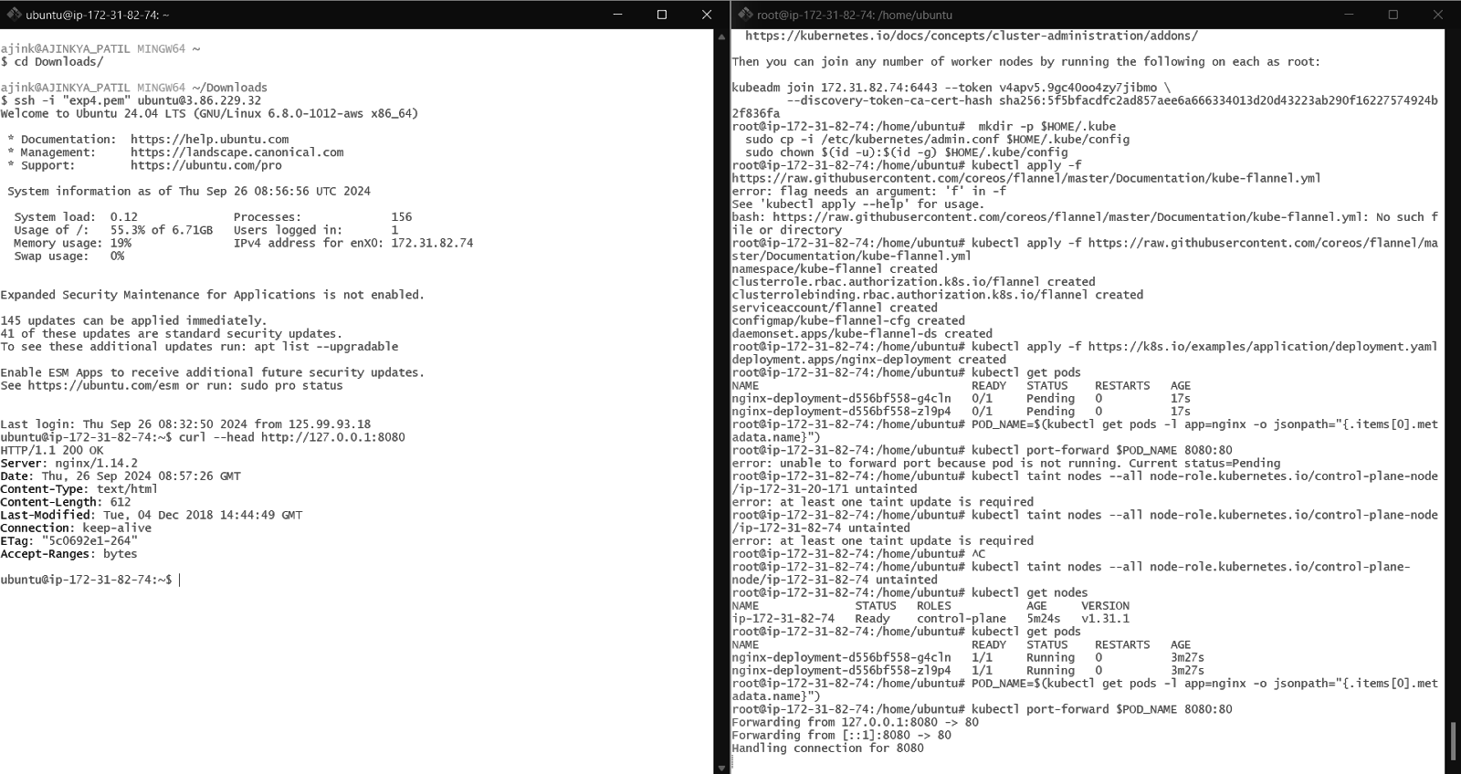

**If the response is 200 OK and you can see the Nginx server name, your deployment was successful.**

**We have successfully deployed our Nginx server on our EC2 instance.**